# Volumetric Analysis

Acid-base reactions, or neutralization reactions, are commonly used to determine the concentrations of acids (or bases) in solutions. When an acid is added to a base (or vice versa) the solution becomes neutral (pH=7) when the moles of H+ are equal to the moles of OH-. Therefore, if the concentration and volume of one of the reactants in a neutralization reaction is known, the concentration of the second solution can be determined if its volume is known. Because titrations involve the measurement of volumes, they are referred to as a type of volumetric analysis.

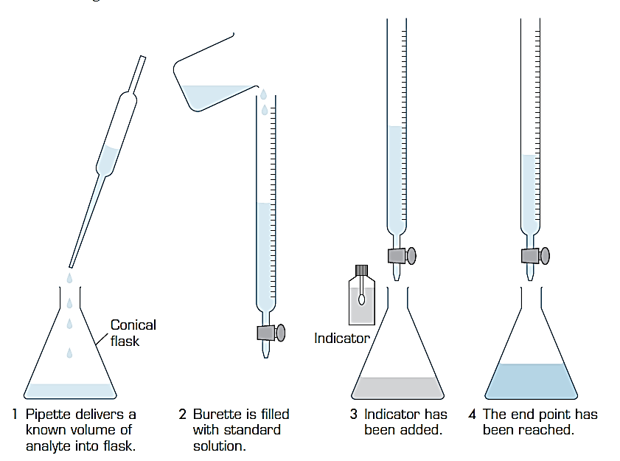

Figure 1: Basic steps of a titration

Titration is a very accurate form of analysis. The basic steps of a titration are shown in figure 1. The first step in a titration is to measure out a known quantity of an acid or base solution

of unknown concentration (the analyte). This is measured into a conical flask using a pipette. The volume added with the pipette is referred to as an aliquot. An indicator is added to this solution.

A burette is filled with a **standard solution (**accurately known concentration - the titrant) and is slowly dispensed from the burette into the conical flask. The concentration of the titrant must be accurately known so that the concentration of the unknown can be calculated. In order to do this, the reaction between the two solutions must also be known.

**Standard Solutions:** A solution has been standardised when it has been titrated against a **primary standard**. A primary standard is a substance that can be obtained in a pure form so that the number of moles can be accurately determined from its mass. For example, sodium hydroxide is commonly used as a standard solution but it is too difficult to obtain pure solid sodium hydroxide. It must first be standardised against a primary standard such as hydrated oxalic acid (H2C2O4.2H2O).

The point in the titration where the acid and the base have reacted exactly with each other to produce a neutral solution is called the **equivalence point**. The point where the indicator begins to change colour is called the **end-point**. The end-point is close to the equivalence point. Titration is complete when there is a permanent colour change. Toward the end of the titration you may need to add the titrant drop by drop, otherwise you may go past the end point. The volume of titrant added is called the titre. This volume is used for the calculations of the concentration of the unknown solution.

**Example of an acid base titration.**

To determine the concentration of a hydrochloric acid solution the following process was completed.

20.00 mL of hydrochloric acid was pipetted into a conical flask, and two drops of phenolphthalein indicator was added. A 0.1019 M sodium hydroxide solution was titrated until the resulting solution turned a permanent pale pink colour. The process was repeated three times and the average titre was 24.20 mL. Determine the concentration of the HCl solution.

Step 1: Write the neutralisation reaction and note the ratios (coefficients) for the reaction

HCl(aq) + NaOH(aq) → NaCl(aq) + H2O(l)

Step 2: Calculate the moles of the standard (known solution), in this case the base NaOH.

*n*(NaOH)  = *C* × *V*

= 0.1019 mol L–1 × 0.02420 L

= 2.466 × 10–3 mol

Step 3: Use the reaction ratios to calculate moles of the unknown solution (the HCl)

The reacting ratio (*n*(HCl):*n*(NaOH)) is = 1:1

therefore *n*(HCl) = *n*(NaOH)

*n*(HCl) = 2.466 × 10–3 mol

Step 4: Calculate the concentration of the unknown solution (HCl)

$${ C}_{(HCl)}= \frac{n}{V}$$

$${ C}_{(HCl)}= \frac{2.466 × {10}^{-3} mol}{0.020 L}$$

= 0.1233 mol L–1

The concentration of the hydrochloric acid is 0.1233 M.

**Example 2**.

Sulphuric acid is sold by chemical supply houses as an approximately 18M stock solution. In an experiment, the 18M stock solution is diluted to approximately 0.3 M. A 25.0 mL aliquot (or portion) of this diluted solution of sulphuric acid requires an average of 32.58 mL of 0.50 M sodium hydroxide for a complete neutralization. What is the molarity of the sulphuric acid solution?

**TITRATION CURVES (pH Curves)**

The end-point of a titration is very useful for determining concentrations of acids and bases, however for some titrations involving weak acids and bases, further information can be obtained from understanding pH changes during the titration. If the pH of an acid solution is plotted against the amount of base added during a titration, the shape of the graph is called a titration curve. All titration curves follow similar but slightly different patterns.

**Titration curves for strong acid v strong base**

We'll take hydrochloric acid and sodium hydroxide as typical of a strong acid and a strong base.

https://www.chemguide.co.uk/physical/acidbaseeqia/padding.gifhttps://www.chemguide.co.uk/physical/acidbaseeqia/naohhcleqn.gif

***Adding a strong base to a strong acid***

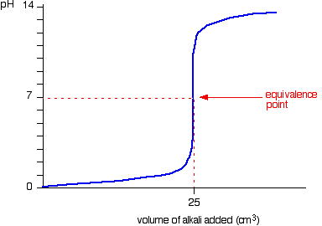

This is very similar to the previous curve except, of course, that the pH starts low and increases as you add more sodium hydroxide solution.

Again, the pH doesn't change very much until you get close to the equivalence point. Then it rapidly increases until there is a significant excess of base. At this point the rate of change of the pH decreases.

***Adding a strong acid to a strong base***

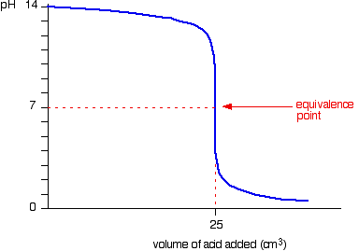

You can see that the pH only falls a very small amount until quite near the equivalence point. Then there is a rapid decrease in the pH.

If you calculate the values, the pH falls all the way from 11.3 when you have added 24.9cm3 to 2.7 when you have added 25.1cm3.

The pH falls until there is a significant excess of acid. At this point the rate at which the pH changes decreases.

**Titration curves for weak base v strong acid**

As an example, consider a titration of hydrochloric acid as the strong acid and ammonia solution as the weak base.

NH3(aq) + HCl(aq) → NH4+(aq) + Cl-(aq)

***Adding a strong acid to a weak base***



Because you have a weak base, the beginning of the curve is going to be different to starting with a strong base.

* At the very beginning of the curve, the pH is high, and the pH starts by falling quite quickly as the acid is added, but the curve very soon gets less steep. This is because a buffer solution is being set up - composed of the excess weak base, ammonia, and its conjugate acid (ammonium anion) forming an equilibrium. This part of the curve is referred to as the **buffer region/zone**.
* At the half-equivalence point (marked with an “x”, half the volume of the equivalence point), the amount of acid added is exactly half the amount of base which was initially present, the pOH will be equal to the pKb of the weak base.
* Notice that the equivalence point is now somewhat acidic (a bit less than pH 5), because pure ammonium isn't neutral. However, the equivalence point still falls on the steepest bit of the curve. That will turn out to be important in choosing a suitable indicator for the titration.

**Titration curves for weak acid v strong base**

As an example, consider a titration of sodium hydroxide as the strong base against ethanoic acid as a weak acid.

***https://www.chemguide.co.uk/physical/acidbaseeqia/padding.gifhttps://www.chemguide.co.uk/physical/acidbaseeqia/naohch3cooh.gif***

***Adding a strong base to a weak acid***

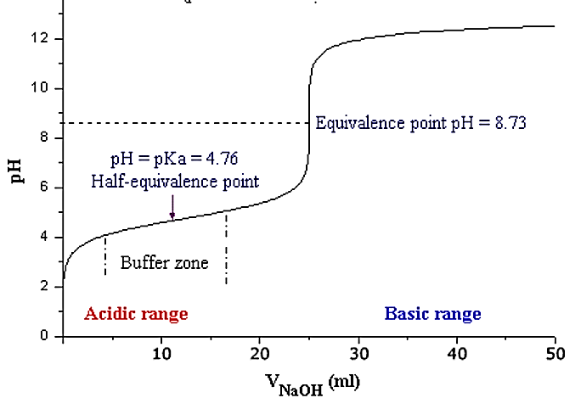

Because you have a weak acid, the beginning of the curve is going to be different to starting with a strong acid.

* At the very beginning of the curve, the pH is low and the pH starts by rising quite quickly as the strong base is added, but the curve very soon gets less steep. This is because a buffer solution is being set up - composed of the excess weak acid (CH3COOH) and its conjugate base (CH3COO-) forming an equilibrium. This part of the curve is referred to as the **buffer region/zone**.
* At the half-equivalence point (marked with an “x”, half the volume of the equivalence point), the amount of base added is exactly half the amount of acid that was initially present, the pH will be equal to the pKa of the weak acid.
* Notice that the equivalence point is now somewhat basic (a bit more than pH 8), because the acetate anion ((CH3COO-) isn't neutral. However, the equivalence point still falls on the steepest bit of the curve. That will turn out to be important in choosing a suitable indicator for the titration.